**FORWARD COLLISION WARNING SYSTEM BASED ON DEEP NEURAL NETWORKS**

***An industry oriented main project report submitted***

***In partial fulfillment of the requirement for the award of the degree of***

**BACHELOR OF TECHNOLOGY**

In

**COMPUTER SCIENCE AND ENGINEERING**

*By*

**K. Akash (15135A0501)**

**B. Akhil (14131A0515)**

**K. Grishma Harivallabhi (14131A0548)**

**D. Sruthi Varma (14131A0528)**

*Under the esteemed guidance of*

**Mr. Ch. Avinash**

**Assistant Professor**



**DEPARTMENT OF COMPUTER SCIENCE AND ENGINEERING**

GAYATRI VIDYA PARISHAD COLLEGE OF ENGINEERING (A)

(AFFILIATED TO JNTU, KAKINADA, AP)

VISAKHAPATNAM – 530048

2014 – 2018

**DEPARTMENT OF COMPUTER SCIENCE AND ENGINEERING**

GAYATRI VIDYA PARISHAD COLLEGE OF ENGINEERING (A)

(AFFILIATED TO JNTU, KAKINADA, AP)

VISAKHAPATNAM – 530048

**CERTIFICATE**

This is to certify that the project work entitled “**FORWARD COLLISION WARNING SYSTEM BASED ON DEEP NEURAL NETWORKS**” being submitted by**K. Akash(15135A0501), B. Akhil(14131A0515), K. Grishma Harivallabhi(14131A0548) and D. Sruthi Varma (14131A0528)** in partial fulfillment of the requirement for the award of the degree of “Bachelor of technology” in Computer Science and Engineering is a record of bonafide work done by them under my supervision during the academic year 2017-2018.

**Internal guide Head of the Department**

**Mr. Ch. Avinash Dr. P. Krishna Subba Rao**

**Assistant Professor Professor & Head of Department CSE GVPCOE(A)** **GVPCOE(A)**

**DECLARATION**

We hereby declare that the project report entitled “**FORWARD COLLISION WARNING SYSTEM BASED ON DEEP NEURAL NETWORKS**” submitted by us to Gayatri Vidya Parishad College of Engineering (Autonomous) in partial fulfillment of the requirement for the award of the degree of B. Tech (Computer Science and Engineering) is a record of bonafide major project work carried out by us under the guidance of Mr**. Ch. Avinash.**

I further declare that the work reported in this major project has not been submitted and will not be submitted, either in part or in full, for the award of any other degree in this institute or any other institute or university

BY

K. Akash(15135A0501)

B. Akhil(14131A0515)

K. Grishma Harivallabhi(14131A0548)

D. Sruthi Varma(14131A0528)

**ACKNOWLEDGEMENT**

We thank **Prof. A.B.K. Rao** principal, **Gayatri Vidya Parishad College of Engineering(A)**  for extending his utmost support and cooperation in providing all the provisions for the successful completion of the project.

We consider it our privilege to express our deepest gratitude to **Dr. P.K. Subba Rao** Professor, Head of the Department, Computer Science and Engineering, for his valuable suggestions and constant motivation that greatly helped the project work to get successfully completed.

We thank Avinash sir for guiding us through the project, and helping us to enhance the project in better way. We thank sir for proposing this topic to us as a main project.

We also thank all the members of the staff in Computer Science Engineering for their sustained help in our pursuits.

We thank all those who contributed directly or indirectly in successfully carrying out his work.

BY

K. Akash(15135A0501)

B. Akhil(14131A0515)

K. Grishma Harivallabhi(14131A0548)

D. Sruthi Varma(14131A0528)

***FORWARD COLLISION WARNING SYSTEM BASED ON DEEP NEURAL NETWORKS***

***Abstract***

**ABSTRACT**

Technology is growing rapidly and the automotive industry is no stranger to this. Collision warning systems are the need of the day be it for human driver assistance or for autonomous cars. Collision detection currently is being done using technologies like radar, lidar, ultrasound etc which are very costly and hence we don’t see them in our regular cars. The motivation behind this project is to build a cost-effective solution based on computer vision. The vehicle dash cam footage is to be processed live and warning should be issued well ahead of a probable collision. We take advantage of Convolutional Neural Networks (CNN) which have shown great accuracy in identifying objects. We train a Convolutional Neural Network to detect cars and pedestrians which a vehicle encounters on the road. Training a neural network on image data is very slow, so we take advantage of a GPU instance on cloud which greatly accelerates our deep learning application. We then estimate tracking distance, velocity and acceleration of our car with the help of comparisons performed over a set of consecutive frames from the video. We will be able to predict an imminent collision ahead of its time, so that the driver can break or maneuver the vehicle out of danger. In this project we are working on Ubuntu 16.04, Google Compute Engine (Google Cloud Platform), Python 3.5,CUDA and openCV.

***Index***

**INDEX**

Page no

1. ABOUT THE PROJECT…………………………………………...... 11

2. PROJECT SCOPE………………………………………………… … 14

2.1 EXISTING SYSTEM…………………………………………. 14

2.2 PROPOSED SYSTEM………………………………………… 15

3. FEASIBILITY REPORT……………………………………………… 17

3.1 TECHNICAL DESCRIPTION………………………………… 18

3.2 MODULES…………………………………………………… 25

3.3 REQUIRED HARDWARE……………………………………… 28

3.4 REQUIRED SOFTWARE……………………………………… 28

3.5 FEASIBILITY TYPES………………………………………… 29

4. ANALYSIS…………………………………………………………… 30

4.1 SRS DOCUMENT……………………………………………… 31

4.2 SCOPE OF DEVELOPMENT………………………………… 32

4.3 CONNECTIVITY ……………………………………………… 34

5. DESIGN…………………………………………………………… 36

5.1 UML SPECIFICATIONS…………………………………………… 37

5.2 UML DIAGRAM………………………………………………… 38

5.2.1 USECASE DIAGRAM………………………………………………39

5.2.2 SEQUENCE DIAGRAM……………………………………………40

5.2.3 ACTIVITY DIAGRAM………………………………………… ….41

5.2.4 STATECHART DIAGRAM…………………………………………42

5.2.5 COMPONENT DIAGRAM………………………………………….43

6. CODING……………………………………………………………… 44

6.1 SAMPLE CODE……………………………………………………. 45

6.2 OUTPUT SCREENS………………………………………………… 54

7. TESTING………………………………………………………………. 63

7.1 LEVELS OF TESTING……………………………………………… 65

8. CONCLUSION………………………………………………………… 67

9. BIBLIOGRAPHY ……………………………………………………… 68

9.1 LIST OF WEBSITES………………………………………………… 69

***About The Project***

**1. ABOUT THE PROJECT**

Throughout the past decade, we have witnessed one of the greatest strides in technology with the focus on autonomous cars. Advancements have accelerated with the participation of the leading car developers including BMW, Ford, Audi, and most recently Google and Tesla entering the ring. Our application of technology will change as we advance towards the reality of self-driving vehicles. Various techniques will be used to allow vehicles to understand their surroundings in a dynamic driving environment, and the vehicle must be able to act in response to specific changes in their environment.

These vehicles require a broad range of technologies and infrastructures to operate properly. Each vehicle is required to continuously collect and interpret vast amounts of information. Every system of the car must work with the surrounding environment, and technological advancements must be made to ensure autonomous vehicles work within several contexts.

Collision detection currently is being done using technology like radar, lidar, ultrasound etc which are very costly. We do not see them in our regular cars. We propose a cost-effective solution using only computer vision. The *dashcam*footage is to be processed live and warning should be issued well ahead of a probable collision. First, *object detection* is done and then we estimate *tracking distance, velocity and acceleration* of our car to warn the driver well ahead.

***Project Scope***

**2. PROJECT SCOPE**

**2.1 Existing System:**

The current system of vehicles have expensive systems like RADAR, LIDAR, sonars, GPS, ultrasonic sensors and motion sensors.

**2.1.1. Problems in Existing system:**

* Using RADAR is very expensive and can’t detect small objects.
* RADAR takes more time to lock on an object. Since radio signals travel freely in air and space, it takes more time to get to the object and back.
* It cannot track if an object is decelerating at more the 1 mph/s. If an object is in motion, it may be a challenge for RADAR systems to collect data from the object.
* If you are using GPS on a battery operated device, there may be a battery failure and you may need an external power supply which is not always possible.
* Sometimes the GPS signals are not accurate due to some obstacles to the signals such as buildings, trees and sometimes by extreme atmospheric conditions such as geomagnetic storms.

**2.2 Proposed System:**

* We are using computer vision for object detection, using the neural networks.
* When it comes to deep learning-based object detection, there are three primary object detection methods namely

i) Faster R-CNN’s

ii) You Only Look Once (YOLO)

iii) Single Shot Detectors (SSD’s)

* Out of these, we are using SSD’s which is originally developed by Google.
* The problem with YOLO is that it leaves much accuracy to be desired.
* The algorithm in SSD is more straightforward and faster than R-CNNs.
* MobileNets are open source models designed by google for resource constrained devices such as your smartphone.
* If we combine both the MobileNet architecture and the Single Shot Detector (SSD) framework, we arrive at a fast, efficient deep learning-based method to object detection.
* We will use the MobileNet SSD + deep neural network (dnn) module in OpenCV to build our object detector.
* We draw bounding boxes on the frames as they are processed, at the same time we also find the height and width of the bounding boxes for later use.
* The normal CPU we use does not process enough frames per second which we need for the urgent situations on the road.
* We use NVIDIA Tesla K80 GPU to speed up the frames per seconds, NVIDIA GPU is one of the resources provided by the Google cloud.
* NVIDIA GPU provides four times the speed compared to the normal CPU we use, thus providing more accuracy
* We use X11 forwarding (X Windows or simply X) a Linux graphical windowing system specifically designed to be used over network connections rather than on an attached display device.
* Since the VM instance does not have a GUI, we make use of ‘X11 forwarding ’to connect to the remote cloud server to perform the computations while showing the visual output on our local system using ssh.
* We then calculate the area of the bounding box to determine the distance between our vehicle and the other vehicles
* We keep a note of this distance and as soon as this distance reaches to a threshold value, we immediately warn the driver.
* This warning is given in the form a beep sound, thus avoiding the collision.

***Feasibility Report***

**3. FEASIBILITY REPORT**

**3.1 Technical Description:**

**3.1.1 Python:**

Python is an interpreted high-level programming language for general-purpose programming. Created by Guido van Rossum and first released in 1991, Python has a design philosophy that emphasizes code readability, and a syntax that allows programmers to express concepts in fewer lines of code, notably using significant white space. It provides constructs that enable clear programming on both small and large scales

Python features a dynamic type system and automatic memory management. It supports multiple programming paradigms, including object-oriented, imperative, functional and procedural, and has a large and comprehensive standard library.[[29]](https://en.wikipedia.org/wiki/Python_(programming_language)#cite_note-About-29)

**3.1.2 Opencv:**

OpenCV (*Open Source Computer Vision*) is a library of programming functions mainly aimed at real-time computer vision. Originally developed by Intel.

OpenCV includes a statistical machine learning library that contains:

* Decision tree learning
* Gradient boosting trees
* Expectation-maximization algorithm
* Artificial neural networks
* Support vector machine (SVM)
* Deep neural networks (DNN)

**3.1.3 Convolutional neural network:**

In machine learning, a convolutional neural network (CNN, or ConvNet) is a class of deep, feed-forward artificial neural networks that has successfully been applied to analyzing visual imagery.

CNNs use a variation of multilayer perceptions designed to require minimal preprocessing. They are also known as shift invariant or space invariant artificial neural networks (SIANN), based on their shared-weights architecture and translation invariant characteristics.

Convolutional networks were inspired by biological processesin that the connectivity pattern between neurons resembles the organization of the animal visual cortex. Individual cortical neurons respond to stimuli only in a restricted region of the visual field known as the receptive field. The receptive fields of different neurons partially overlap such that they cover the entire visual field.

CNNs use relatively little pre-processing compared to other image classification algorithms. This means that the network learns the filters that in traditional algorithms were hand-engineered. This independence from prior knowledge and human effort in feature design is a major advantage.

They have applications in image and video recognition, recommender systems and natural language processing.

**3.1.4 Google Cloud Platform:**

Google Cloud Platform, offered by Google, is a suite of cloud computing services that runs on the same infrastructure that Google uses internally for its end-user products, like Google Search and YouTube. Alongside a set of management tools, it provides a series of modular cloud services including computing, data storage, data analytics and machine learning. Registration requires a credit card or bank account details.

A sample of products are listed below, this is not an exhaustive list.

* App Engine – PaaS for application hosting.
* BigQuery – IaaS large scale database analytics.
* Bigtable – IaaS massively scalable NoSQL database.
* Cloud AutoML – suite of Machine Learning products that allow developers with limited machine learning expertise to leverage Google’s transfer learning and Neural Architecture Search technology. Image labeling service available.
* Cloud Datastore – DBaaS providing a document-oriented database.
* Cloud Functions – FaaS providing serverless functions to be triggered by cloud events.
* Cloud Machine Learning Engine – Managed machine learning as a service for training and executing Tensorflow models.
* Cloud Pub/Sub – a service for publishing and subscribing to data streams and messages. Applications can communicate via Pub/Sub, without direct integration between the applications themselves.
* Compute Engine – IaaS providing virtual machines.
* Kubernetes Engine – A managed container orchestration service for Kubernetes.
* Storage – IaaS providing RESTful online file and object storage.

**3.1.5 X11 forwarding:**

The X Window System (X11, or shortened to simply X) is a windowing system for bitmap displays, common on UNIX-like computer operating systems. X is an architecture-independent system for remote graphical user interfaces and input device capabilities. Each person using a networked terminal has the ability to interact with the display with any type of user input device. X uses a client–server model: an X server communicates with various *client* programs. The server accepts requests for graphical output (windows) and sends back user input (from keyboard, mouse, or touchscreen). The server may function as:

* an application displaying to a window of another display system
* a system program controlling the video output of a PC
* a dedicated piece of hardware

To use an X client application on a remote machine, the user may do the following:

* on the local machine, open a terminal window
* use ssh with the X forwarding argument to connect to the remote machine
* request local display/input service (*e.g.*, export DISPLAY=*[user's machine]*:0 if not using SSH with X forwarding enabled)

**3.1.6 NVIDIA GPU:**

A **graphics processing unit** (**GPU**) is a specialized electronic circuit designed to rapidly manipulate and alter memory to accelerate the creation of images in a frame buffer intended for output to a display device. GPUs are used in embedded systems, mobile phones, personal computers, workstations, and game consoles. Modern GPUs are very efficient at manipulating computer graphics and image processing, and their highly parallel structure makes them more efficient than general-purpose CPUs for algorithms where the processing of large blocks of data is done in parallel. In a personal computer, a GPU can be present on a video card, or it can be embedded on the motherboard or—in certain CPUs—on the CPU die.

The **GPU Technology Conference** is an annual technical conference started by Nvidia in 2009 which focuses on using the GPU to solve computing challenges.

Nvidia GPUs are used in deep learning, artificial intelligence, and accelerated analytics. The company developed GPU-based deep learning in order to use artificial intelligence to approach problems like cancer detection, weather prediction, and self-driving vehicles. They are included in all Tesla vehicles. The purpose is to help networks learn to “think”. According to *TechRepublic*, Nvidia GPUs "work well for deep learning tasks because they are designed for parallel computing and do well to handle the vector and matrix operations that are prevalent in deep learning". These GPUs are used by researchers, laboratories, tech companies and enterprise companies. In 2009, Nvidia was involved in what was called the "big bang" of deep learning, "as deep-learning neural networks were combined with Nvidia graphics processing units (GPUs)". That year, the Google Brain used Nvidia GPUs to create Deep Neural Networks capable of machine learning, where Andrew Ng determined that GPUs could increase the speed of deep-learning systems by about 100 times.

**3.1.7 CUDA:**

**CUDA** is a parallel computing platform and application programming interface (API) model created by Nvidia. It allows software developers and software engineers to use a CUDA-enabled graphics processing unit (GPU) for general purpose processing – an approach termed GPGPU (General-Purpose computing on Graphics Processing Units). The CUDA platform is a software layer that gives direct access to the GPU's virtual instruction set and parallel computational elements, for the execution of compute kernels.

CUDA has several advantages over traditional general-purpose computation on GPUs (GPGPU) using graphics APIs:

* Scattered reads – code can read from arbitrary addresses in memory
* Unified virtual memory (CUDA 4.0 and above)
* Unified memory (CUDA 6.0 and above)
* Shared memory – CUDA exposes a fast shared memory region that can be shared among threads. This can be used as a user-managed cache, enabling higher bandwidth than is possible using texture lookups.
* Faster downloads and readbacks to and from the GPU
* Full support for integer and bit-wise operations, including integer texture lookups

**3.1.8 Caffe deep learning framework:**

CAFFE (Convolutional Architecture for Fast Feature Embedding) is a deep learning framework, originally developed at UC Berkeley. It is open source, under a BSD license. It is written in C++, with a Python interface.

Caffe supports many different types of deep learning architectures geared towards image classification and image segmentation. It supports CNN, RCNN, LSTM and fully connected neural network designs. Caffe supports GPU-based acceleration using CuDNN of Nvidia.

Caffe is being used in academic research projects, startup prototypes, and even large-scale industrial applications in vision, speech, and multimedia. Yahoo! Has also integrated caffe with Apache Spark to create CaffeOnSpark, a distributed deep learning framework.

**3.2 MODULES**

The system after careful analysis has been identified to present with the following modules.

1. **Object Detection Module**:

* We take the video feed from the dash cam of the vehicle.
* We upload the video file to the google cloud and give it as input to the python file in the cloud.
* We import opencv and other required packages in python.
* In OpenCV, a video can be read either by using the feed from a camera connected to a computer or by reading a video file. The first step towards reading a video file is to create a VideoCapture object. Its argument can be either the device index or the name of the video file to be read. Example **cap = cv2.VideoCapture(0)**
* In most cases, only one camera is connected to the system. So, all we do is pass ‘0’ and OpenCV uses the only camera attached to the computer. When more than one camera is connected to the computer, we can select the second camera by passing ‘1’, the third camera by passing ‘2’ and so on.
* We then grab the frames from the video using **cap.read()**
* We then normalize each frame by converting the image into blob(**B**inary **L**arge **OB**ject) with 300x300 resolution, for faster processing.
* Due to the 4-connectivity and 8- connectivity definitions in blob, it helps in detections more efficiently.
* We Pass the blob through the network and obtain the detections and predictions
* We set the input to the network and compute the forward pass for the input, storing the result as detections.
* We start by looping over our detections, keeping in mind that multiple objects can be detected in a single image.
* We also apply a check to the confidence (i.e., probability) associated with each detection. If the confidence is high enough (i.e. above the threshold), then we’ll display the prediction in the terminal as well as draw the prediction on the image with text and a colored bounding box.
  + Finally, we display the resulting output image to the screen until a key is pressed.

1. **Distance Estimation Module:**

* Using X11 forwarding, we transfer the output from the cloud to the system since google VM instance is not having the GUI.
* Once we have the bounding boxes we find the height and width of the bounding boxes.
* Using the height and width, we calculate the area of the bounding box
* With the help of the area found we estimate the distance of the vehicle from the dash cam.
* When the value of the area reaches the threshold we set a trigger.

1. **Warning system module**:

* Once the value crosses the threshold value, we send an alert in the form of a beep sound to the driver.

**3.3 REQUIRED HARDWARE:**

Hardware requirements

* System : Google Cloud VM instance(Ubuntu 16.04 LTS)
* Hard Disk : 60 GB
* Floppy Drive : none
* Monitor : 1024 x 768 monitor (color)
* Ram : 8 GB

**3.4 REQUIRED SOFTWARE:**

Software requirements

* Operating system : UBUNTU(16.04 LTS),
* Coding Language : Python 3
* Tool Kit : Opencv- python, Caffe(Framework)
* IDE : none

**3.5 FEASIBILITY TYPES:**

**Technical feasibility:**

The technical issue usually raised during the feasibility stage of the investigation includes the following:

* Does the necessary technology exist to do what is suggested?
  + Yes, all we need is a dash cam and a good internet connection.
* Do the proposed equipments have the technical capacity to hold the data required to use the new system?
  + Yes, the proposed equipments have the technical capacity to hold the data required to use the new system. We are using NVIDIA GPU and 8GB ram. And we are using Buckets to upload the files, just by doing a drag and drop.
* Can the system be upgraded if developed?
  + Yes, the system can be upgraded by using stereo cameras which have two lenses.
* Is your project cost-effective when compared to other alternatives?
  + Yes, the project is cost-effective when compared to other costlier alternatives like LIDAR, RADAR.

**Financial Feasibility:** cloud based storage provides low computer cost, improved performance and reduced software cost. The GPU (NVIDIA) provided by the cloud (google) is worth $35.

***Analysis***

***Report***

**4. ANALYSIS REPORT**

**4.1 SRS DOCUMENT**

**Intended Audience and Reading Suggestions**

The document is prepared keeping in view of the academic constructs of my Bachelor’s Degree from university as partial fulfillment of my academic purpose the document specifies the general procedure that that has been followed by me, while the system was studied and developed. The general document was provided by the industry as a reference guide to understand my responsibilities in developing the system, with respect to the requirements that have been pinpointed to get the exact structure of the system as stated by the actual client.

The system as stated by my project leader the actual standards of the specification were desired by conducting a series of interviews and questionnaires. The collected information was organized to form the specification document and then was modeled to suite the standards of the system as intended.

**Document Conventions:**

The overall documents for this project use the recognized modeling standards at the software industries level.

* + The Physical dispense, which state the overall data search for the relational key whereas a transaction is implemented on the wear entities.
  + Unified modeling language concepts to give a generalized blue print for the overall system.
  + The standards of flow chart at the required states that are the functionality of the operations need more concentration.

**4.2 SCOPE OF DEVELOPMENT**

**4.2.1 Future scope:**

**Stereo cameras:**

A stereo camera is a type of camera with two or more lenses with a separate image sensor or film frame for each lens. This allows the camera to simulate human binocular vision, and therefore gives it the ability to capture three-dimensional images, a process known as stereo photography. Stereo cameras may be used for making stereo views and 3D pictures for movies, or for range imaging. The distance between the lenses in a typical stereo camera (the intra-axial distance) is about the distance between one's eyes (known as the intra-ocular distance) and is about 6.35 cm, though a longer baseline (greater inter-camera distance) produces more extreme 3-dimensionality.

Humans have the ability to roughly estimate the distance of objects because of the stereo vision of human eyes. An improved stereo vision system is proposed to accurately measure the distance between the vehicle and the objects around it using two cameras.

**Cheaper GPU:**

AMD's Vega 56 and 64 are running at $800 to $1,500 — and that's if you can even find a card. GTX 1060s are floating around $390, the cheapest. GTX 1070 or 1080 ships in an eGPU chassis for $700 (oddly, both the 1070 and 1080 are$700) and a GTX 1080 standalone will cost you an easy $750 to $1,200.

In the near future the prices will drop and GPUs will be available to all people at a cheap rate.

#### 4.3 CONNECTIVITY

**X11 Forwarding:**

X11 forwarding is possible with the help of SSH.

**Secure Shell** (**SSH**) is a cryptographic network protocol for operating network services securely over an unsecured network. The best known example application is for remote login to computer systems by users.

SSH provides a secure channel over an unsecured network in a client-server architecture, connecting an SSH client application with an SSH server.Common applications include remote command-line login and remote command execution, but any network service can be secured with SSH. The protocol specification distinguishes between two major versions, referred to as SSH-1 and SSH-2.

The most visible application of the protocol is for access to shell accounts on Unix-like operating systems. In 2015, Microsoft announced that they would include native support for SSH in a future release.

* The server side and client side are both connected to X11.
* On the client side, the connection is made by using the following command

**→ ssh -X -i root/.ssh/my-ssh-key <username>@<external ip address>**

* On the server side also the connection is established.
* Then we run the script on the server side google cloud in this case, and produce the output on the client side.

***Design***

***Document***

**5. Design Document**

**5.1 Unified Modeling Language Specifications:**

* The unified modeling language allows the software engineer to express an analysis model using the modeling notation that is governed by a set of syntactic, semantic and pragmatic rules.
* A UML system is represented using five different views that describe the system from distinctly different perspective. Each view is defined by a set of diagram, as follows.

**5.1.1 User Model View:**

* This view represents the system from the user’s perspective.
* The analysis representation describes a usage scenario from the end users perspective.

**5.1.2 Structural model view:**

* In this model the data and functionality are arrived from inside the system. This model view models the static structures

**5.1.3 Behavioral Model View:**

* It represents the dynamic of behavioral as parts of the system, depicting the interactions of collection between various structural elements described in the user model and structural model view.

**5.1.4 Implementation Model View:**

* In this the structural and behavioral as parts of the system are represented as they are to be built.

**5.2 UML:**

* UML is specifically constructed through two different domains they are UML Analysis modeling, this focuses on the user model and structural model views of the system.
* UML Design modeling, this focuses on the behavioral modeling, implementation modeling and environmental model views.

**1. USE CASE DIAGRAM:**

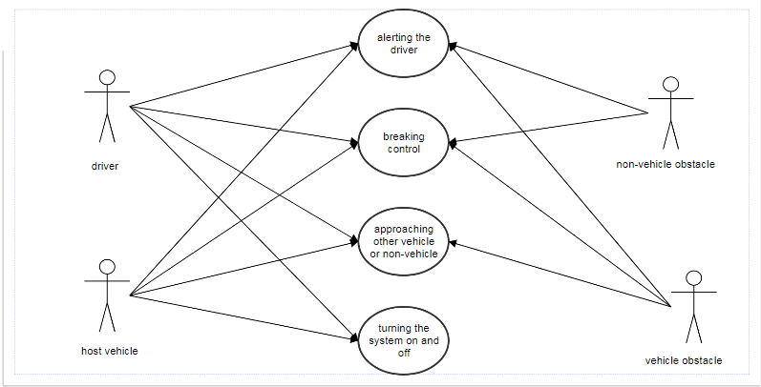

**2. SEQUENCE DIAGRAM:**

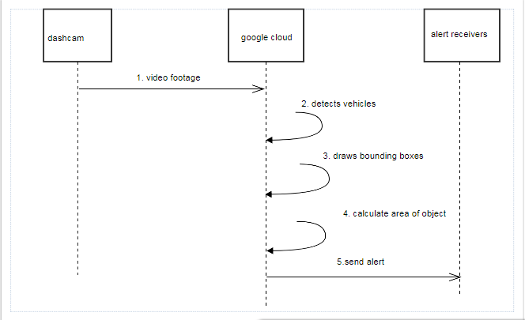

**3. ACTIVITY DIAGRAM:**

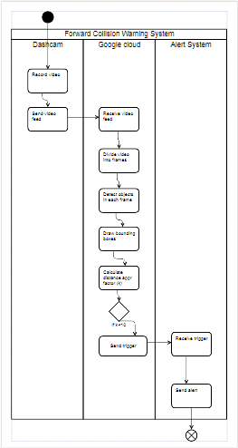

**4. Statechart diagram:**

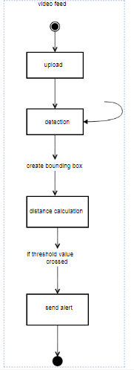

**5. Component Diagram:**

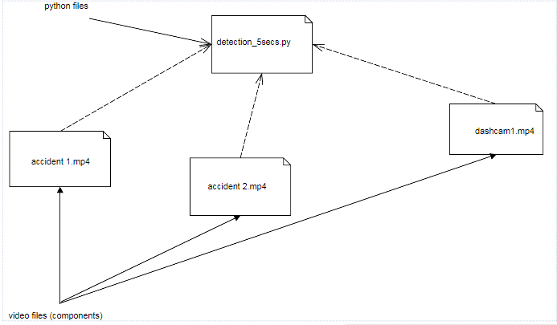

***Coding***

**6. CODING**

**6.1** python **deep_learning_video_detection.py**

#USAGE  
# python deep_learning_object_detection.py --image images/example_01.jpg \  
#--prototxt MobileNetSSD_deploy.prototxt.txt --model MobileNetSSD_deploy.caffemodel  
  
# python detection_5secs.py --prototxt prototxt.txt --model model  
# above line is for videos  
  
  
# import the necessary packages  
import numpy as np  
import argparse  
import cv2  
import sched, time  
import imutils  
  
val=0  
  
# construct the argument parse and parse the arguments  
ap = argparse.ArgumentParser()  
ap.add_argument("-i", "--image", required=False,  
 help="path to input image")  
ap.add_argument("-p", "--prototxt", required=True,  
 help="path to Caffe 'deploy' prototxt file")  
ap.add_argument("-m", "--model", required=True,  
 help="path to Caffe pre-trained model")  
ap.add_argument("-c", "--confidence", type=float, default=0.2,  
 help="minimum probability to filter weak detections")  
args = vars(ap.parse_args())  
  
  
# initialize the list of class labels MobileNet SSD was trained to  
# detect, then generate a set of bounding box colors for each class  
CLASSES = ["background", "aeroplane", "bicycle", "bird", "boat",  
 "bottle", "bus", "vehicle", "cat", "chair", "cow", "diningtable",  
 "dog", "horse", "motorbike", "person", "pottedplant", "sheep",  
 "sofa", "train", "tvmonitor"]  
COLORS = np.random.uniform(0, 255, size=(len(CLASSES), 3))  
  
# load our serialized model from disk  
print("[INFO] loading model...")  
net = cv2.dnn.readNetFromCaffe(args["prototxt"], args["model"])  
  
# load the input image and construct an input blob for the image  
# by resizing to a fixed 300x300 pixels and then normalizing it  
# (note: normalization is done via the authors of the MobileNet SSD  
# implementation)  
  
cap = cv2.VideoCapture("input_video.mp4")  
frame_width = int(cap.get(3))  
frame_height = int(cap.get(4))  
  
fourcc =cv2.VideoWriter_fourcc(*'XVID')  
out = cv2.VideoWriter('output.avi', fourcc, 20.0, (frame_width, frame_height))  
  
while True:  
  
 ret, image = cap.read()  
 (h, w) = image.shape[:2]# height , width   
 blob = cv2.dnn.blobFromImage(cv2.resize(image, (300, 300)), 0.007843, (900, 900), 127.5)  
  
 # pass the blob through the network and obtain the detections and  
 # predictions  
  
 net.setInput(blob)  
 detections = net.forward()  
  
 # loop over the detections  
 for i in np.arange(0, detections.shape[2]):  
 # extract the confidence (i.e., probability) associated with the  
 # prediction  
 confidence = detections[0, 0, i, 2]  
   
 # filter out weak detections by ensuring the `confidence` is  
 # greater than the minimum confidence  
 if confidence > args["confidence"]:  
 # extract the index of the class label from the `detections`,  
 # then compute the (x, y)-coordinates of the bounding box for  
 # the object  
 idx = int(detections[0, 0, i, 1])  
   
 if idx == 7 or idx == 15 :#only cars-7 and pedestrians-15  
 box = detections[0, 0, i, 3:7] * np.array([w, h, w, h])  
 (startX, startY, endX, endY) = box.astype("int")  
  
 # display the prediction  
 label = "{}: {:.2f}%".format(CLASSES[idx], confidence * 100)  
   
 cv2.rectangle(image, (startX, startY), (endX, endY),  
 COLORS[idx], 2)  
 y = startY - 15 if startY - 15 > 15 else startY + 15  
 cv2.putText(image, label, (startX, y),  
 cv2.FONT_HERSHEY_SIMPLEX, 0.5, COLORS[idx], 2)  
  
 out.write(image)   
 cv2.imshow("Output", image)  
   
 if val==1:  
 cv2.destroyAllWindows()  
 print main_func('result.png')  
 break  
 if cv2.waitKey(33)==27:  
 cap.release()  
 out.release()  
 break  
   
cv2.waitKey(0)

**prototext.txt:**

name: "MobileNet-SSD"

input: "data"

input_shape {

dim: 1

dim: 3

dim: 300

dim: 300

}

**// sample layer**

layer {

name: "conv0"

type: "Convolution"

bottom: "data"

top: "conv0"

param {

lr_mult: 1.0

decay_mult: 1.0

}

param {

lr_mult: 2.0

decay_mult: 0.0

}

convolution_param {

num_output: 32

pad: 1

kernel_size: 3

stride: 2

weight_filler {

type: "msra"

}

bias_filler {

type: "constant"

value: 0.0

}

}

}

layer {

name: "conv0/relu"

type: "ReLU"

bottom: "conv0"

top: "conv0"

}

layer {

name: "conv1/dw"

type: "Convolution"

bottom: "conv0"

top: "conv1/dw"

param {

lr_mult: 1.0

decay_mult: 1.0

}

param {

lr_mult: 2.0

decay_mult: 0.0

}

convolution_param {

num_output: 32

pad: 1

kernel_size: 3

group: 32

engine: CAFFE

weight_filler {

type: "msra"

}

bias_filler {

type: "constant"

value: 0.0

}

}

}

**// Detection Output**

layer {

name: "detection_out"

type: "DetectionOutput"

bottom: "mbox_loc"

bottom: "mbox_conf_flatten"

bottom: "mbox_priorbox"

top: "detection_out"

include {

phase: TEST

}

detection_output_param {

num_classes: 21

share_location: true

background_label_id: 0

nms_param {

nms_threshold: 0.45

top_k: 100

}

code_type: CENTER_SIZE

keep_top_k: 100

confidence_threshold: 0.25

}

}

**6.2 Output Screen :**

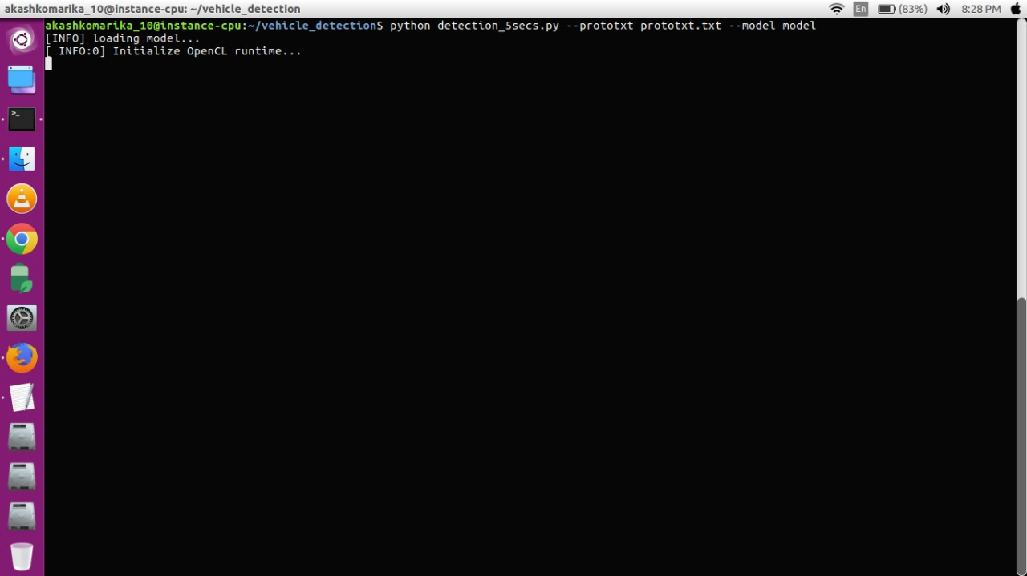

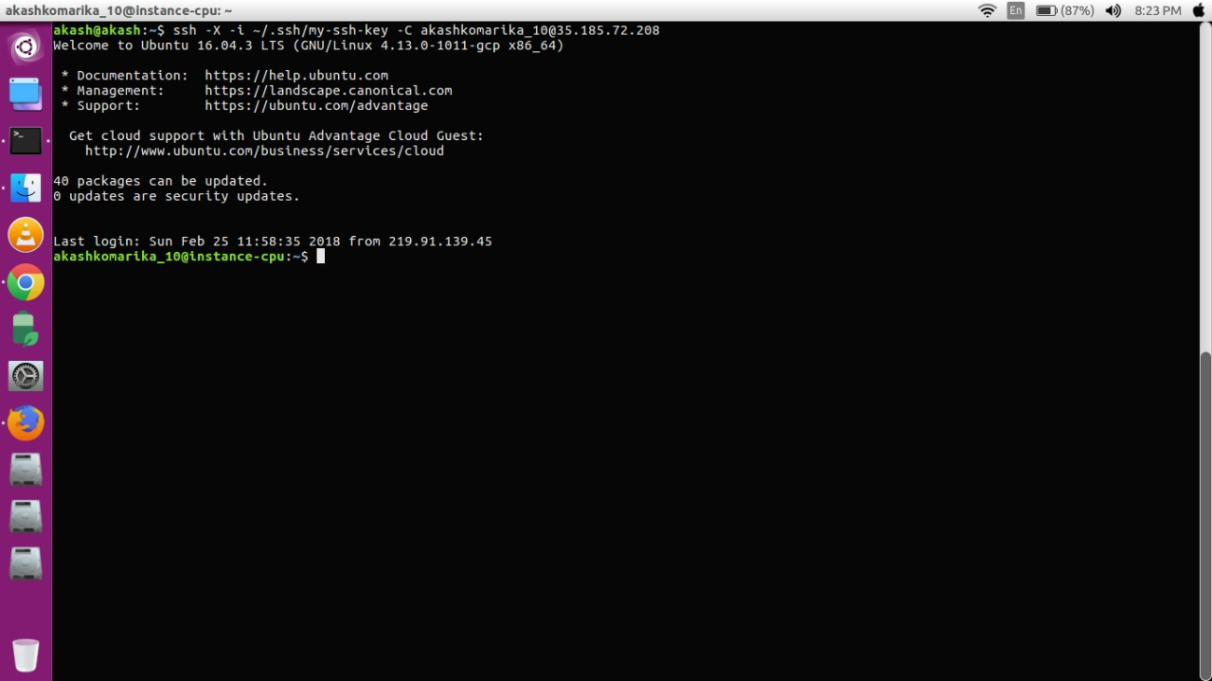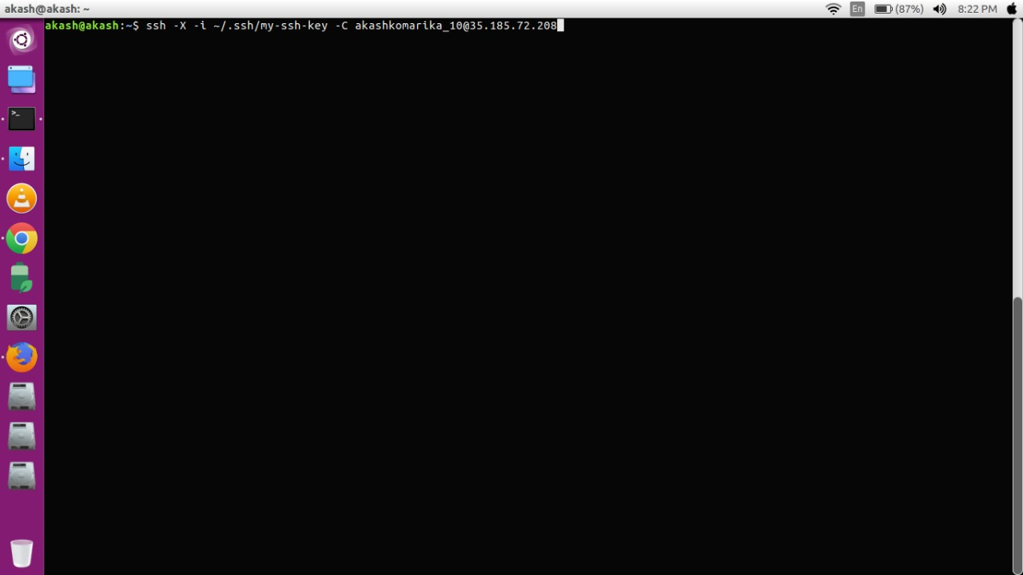

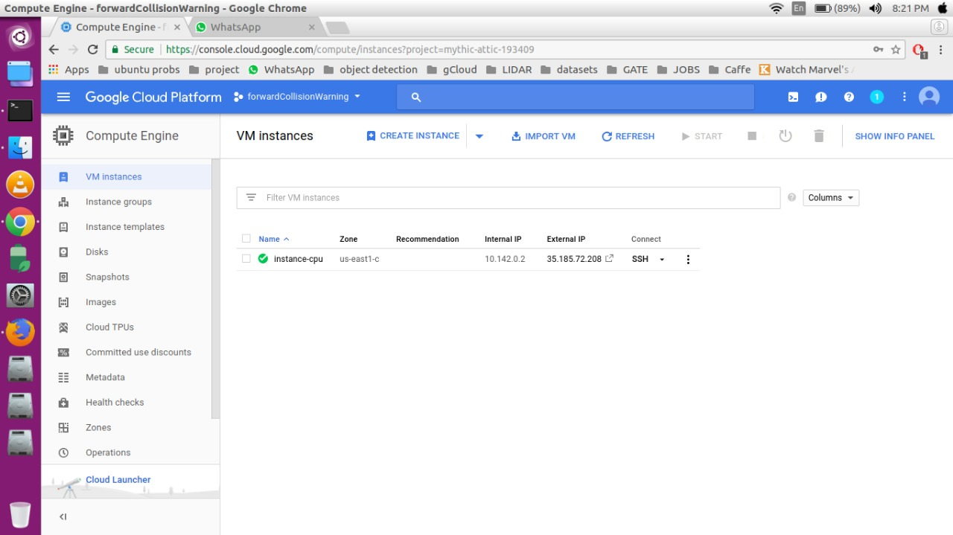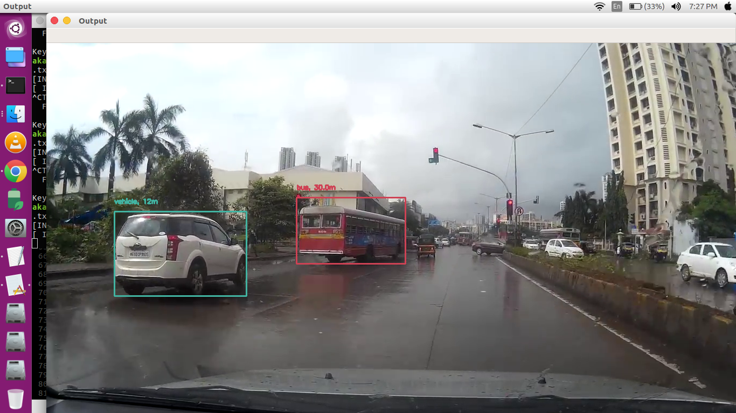

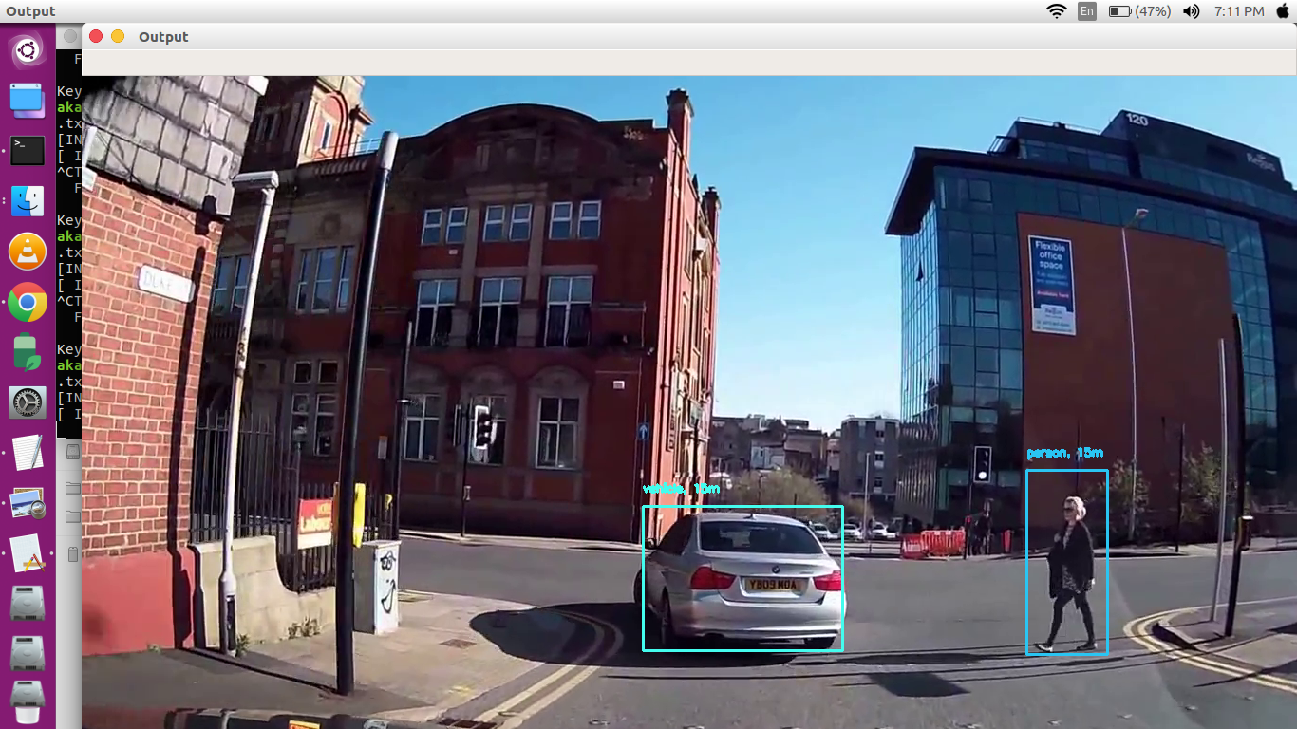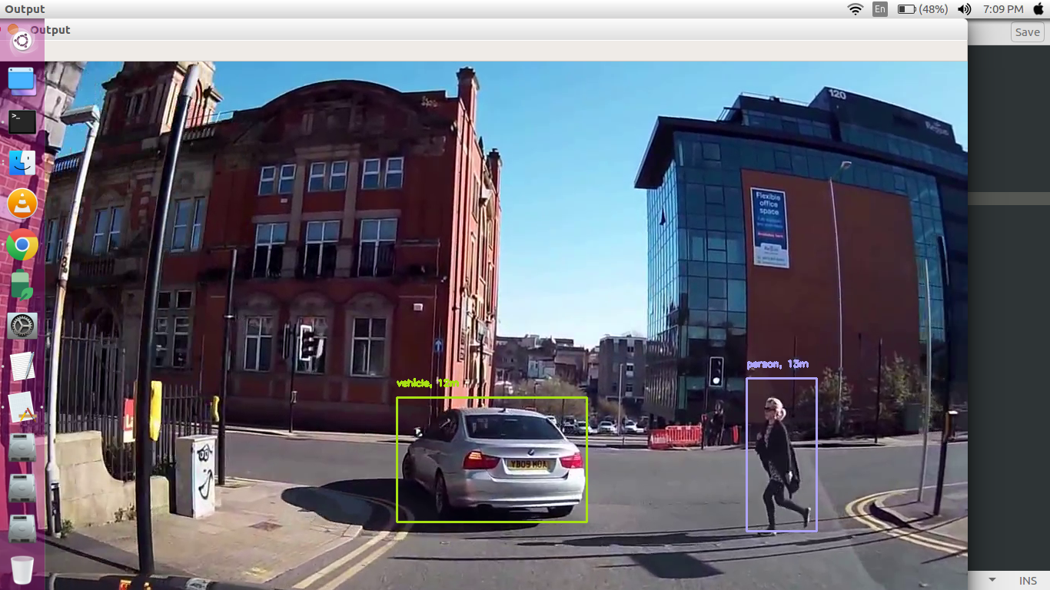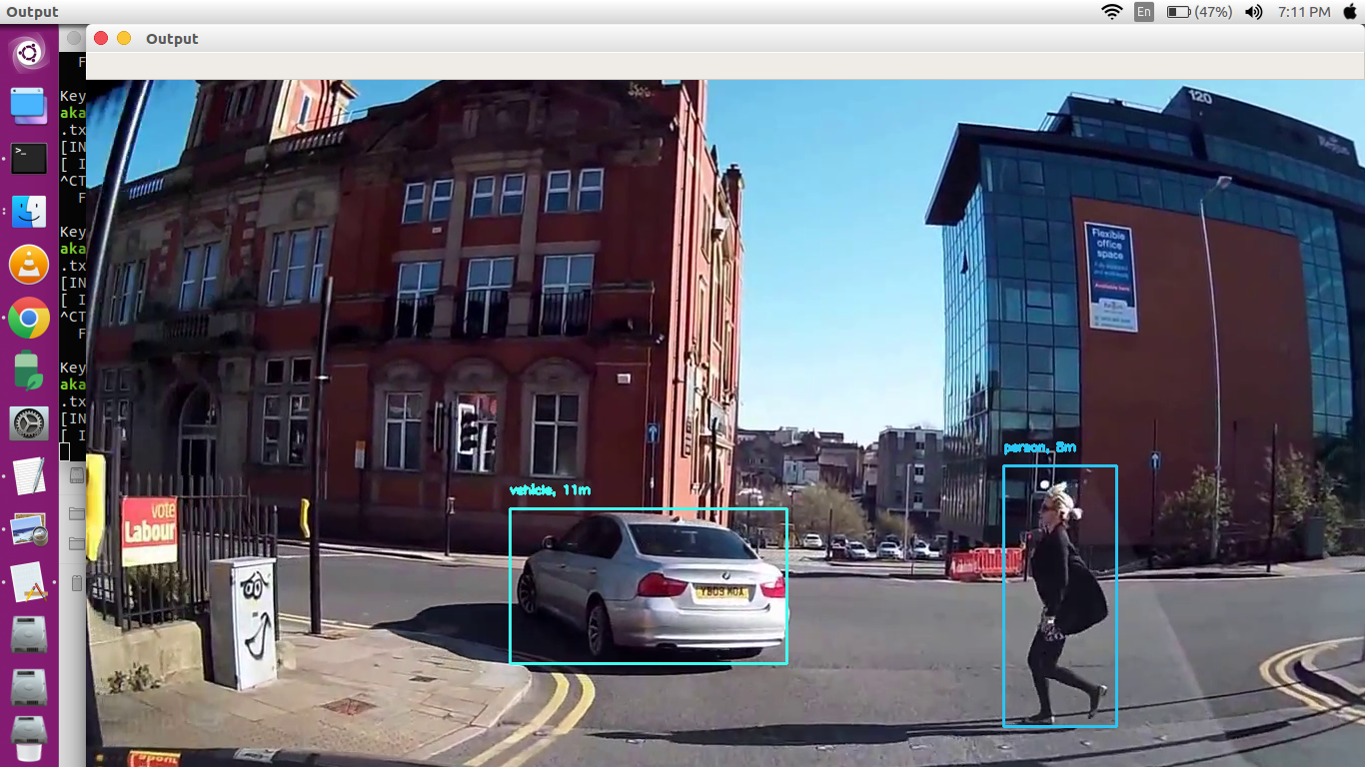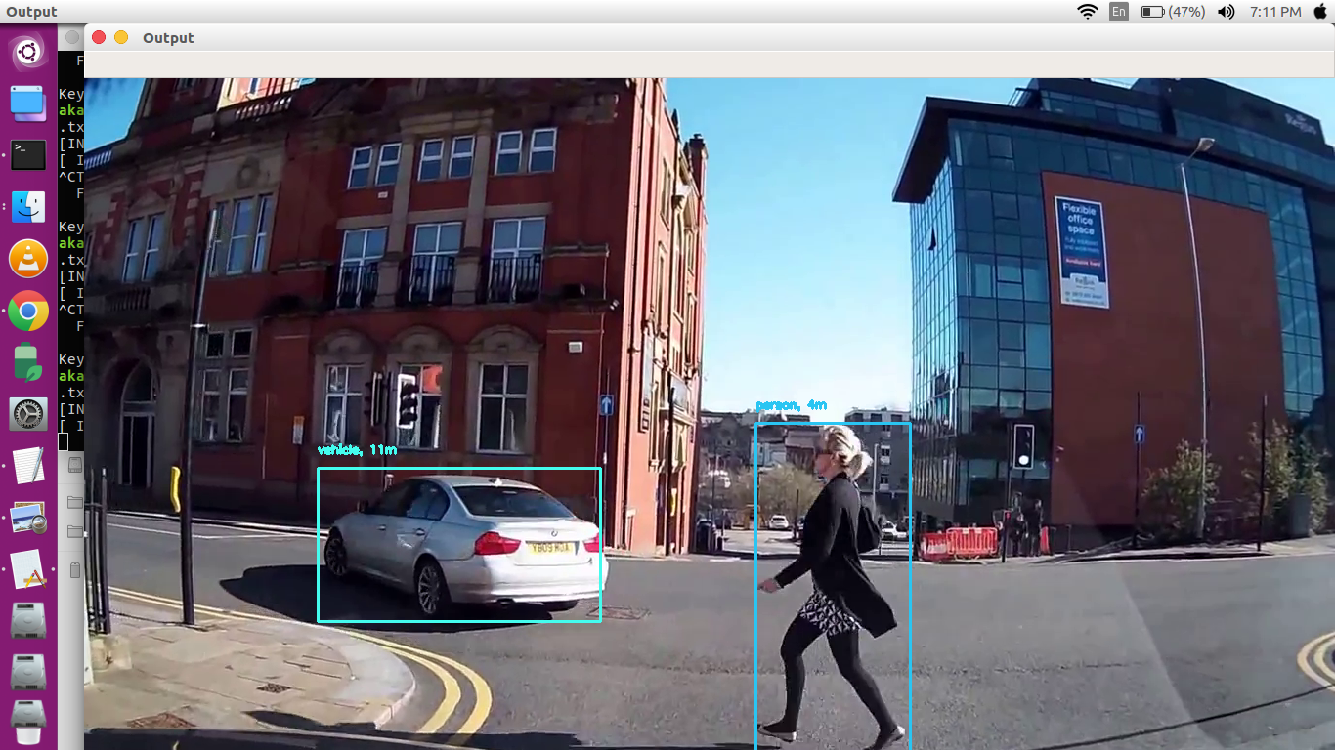

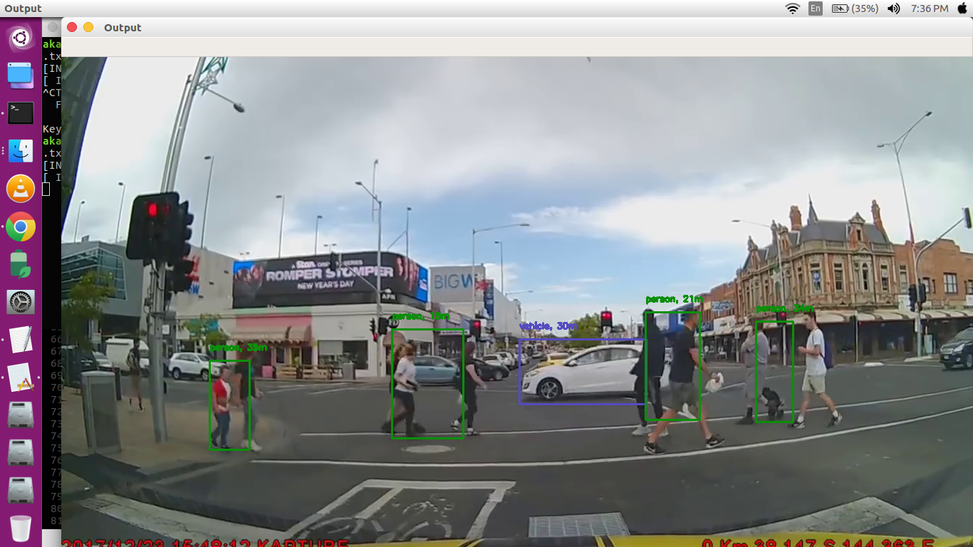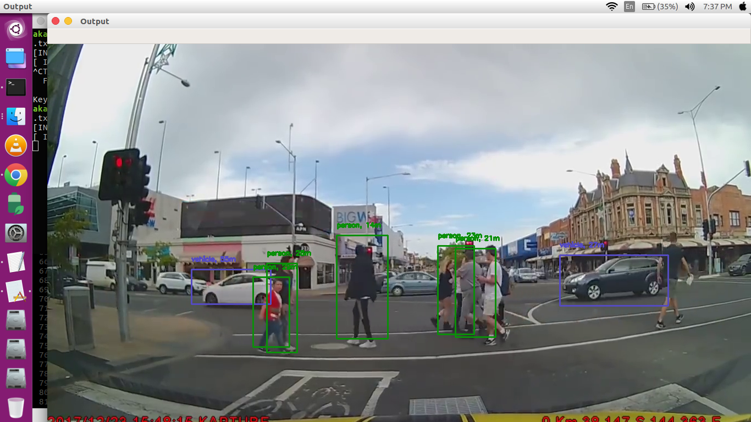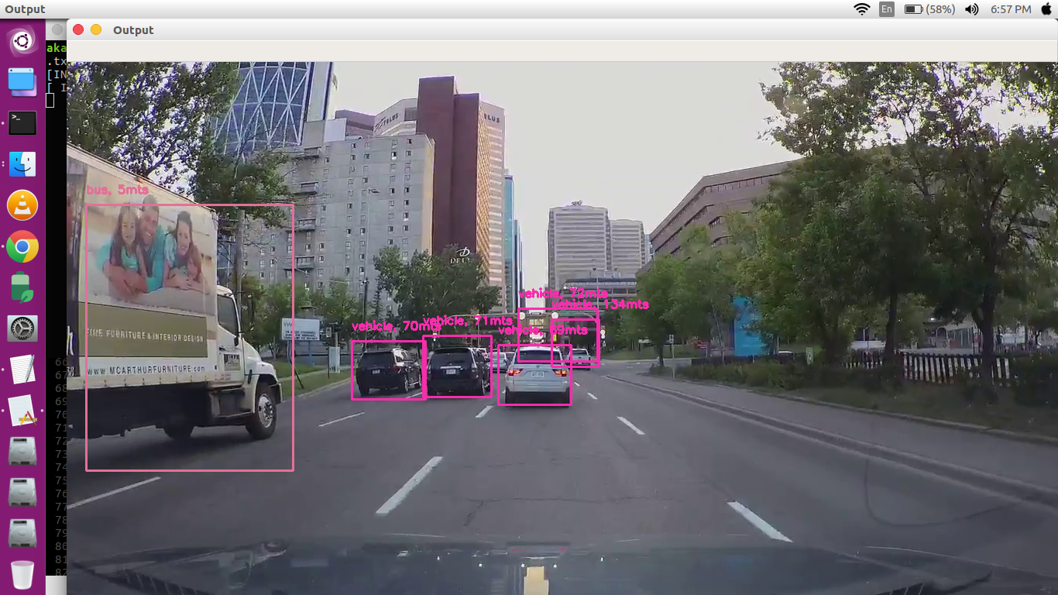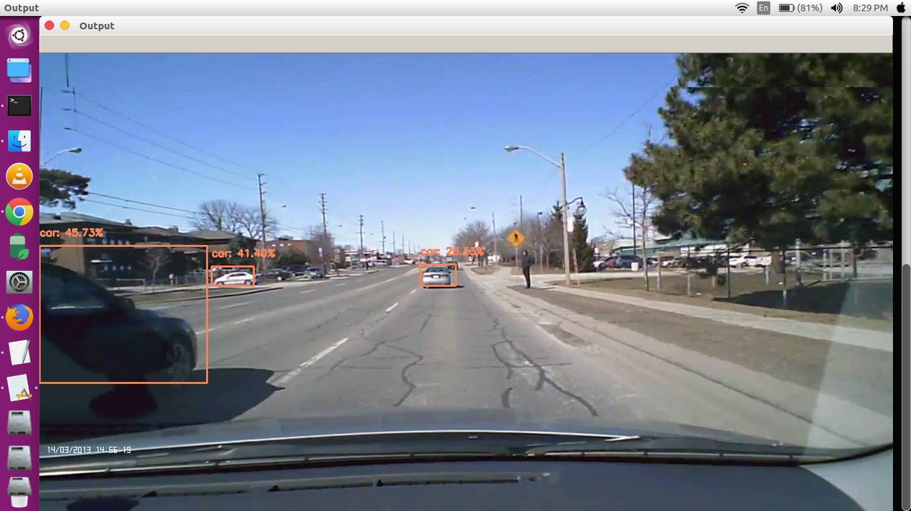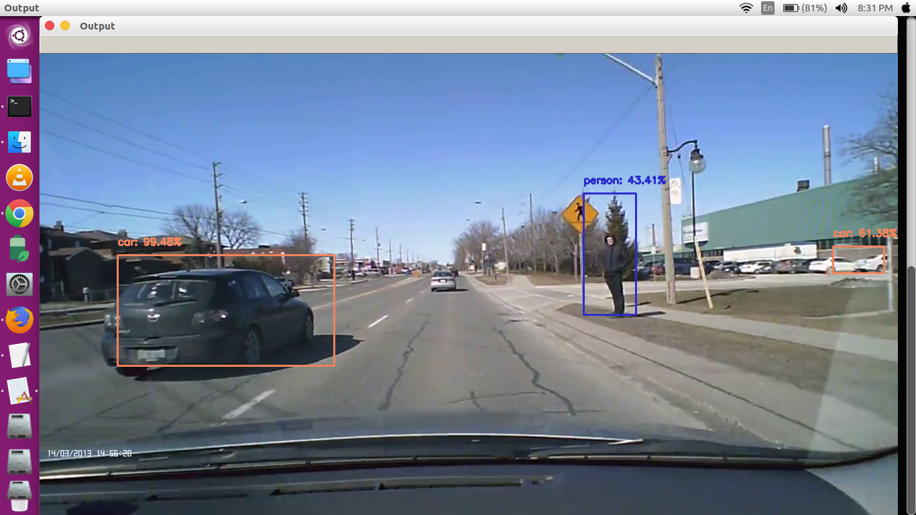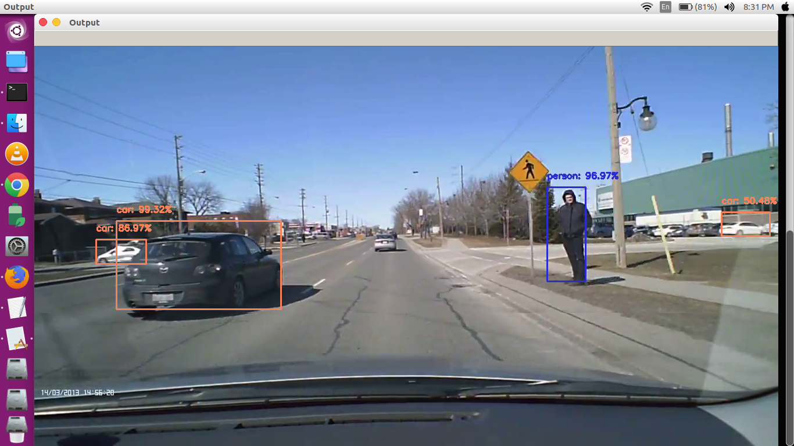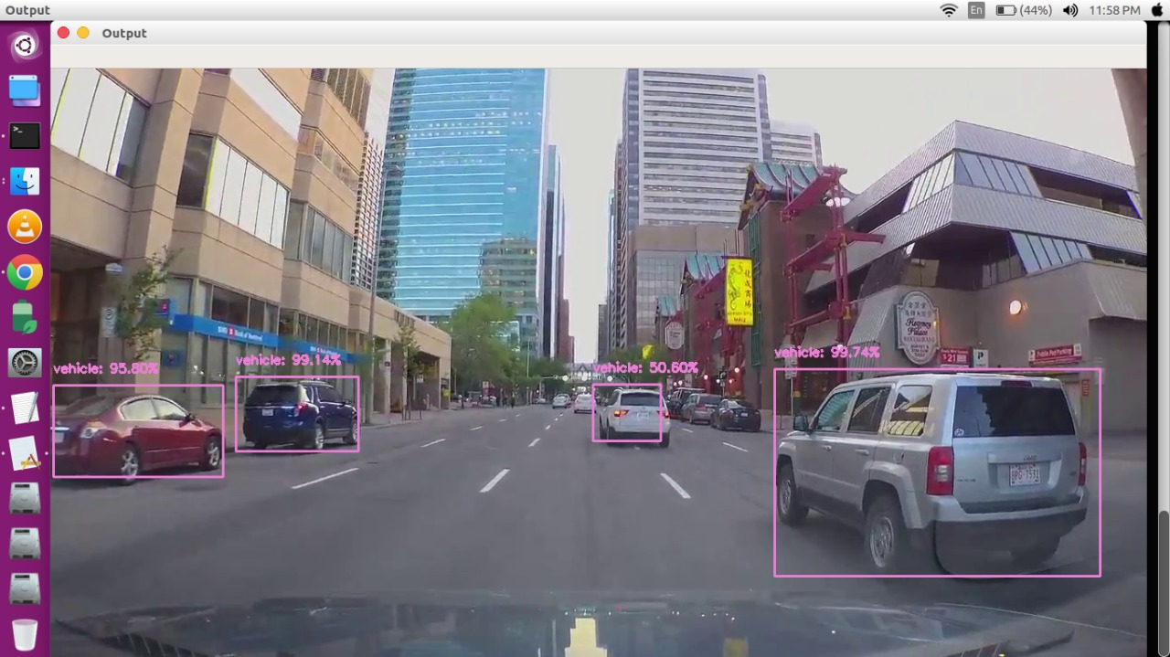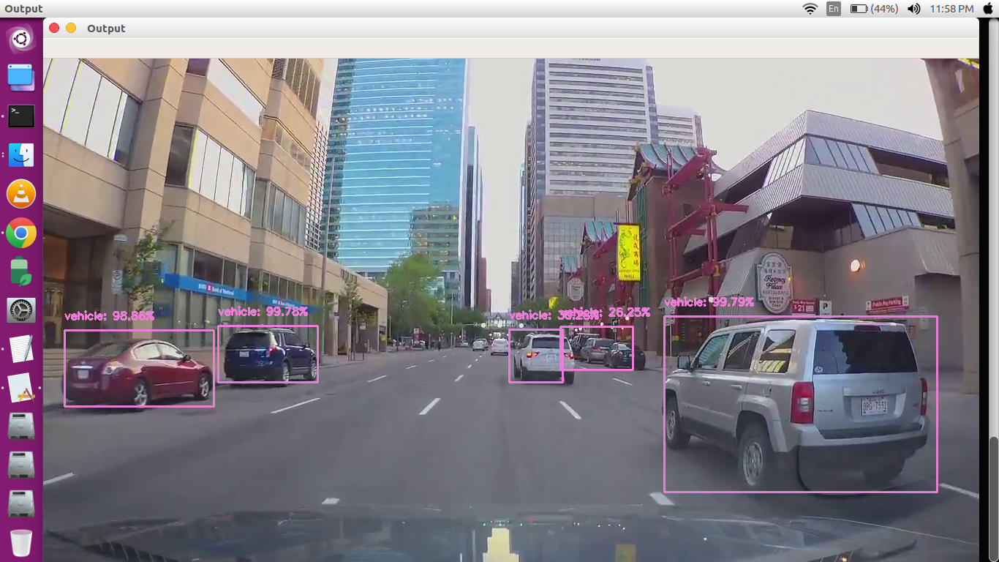

***Testing***

**7. TESTING**

**Testing :**

Testing is the process of detecting errors. Testing performs a very critical role for quality assurance and for ensuring the reliability of software. The results of testing are used later on during maintenance as well.

**Purpose of Testing:**

The aim of testing is often to demonstrate that a program works by showing that it has no errors. The basic purpose of testing phase is to detect the errors that may be present in the program. Hence, one should not start testing with the intent of showing that a program works, but the intent should be to show that a program doesn’t work. Testing is the process of executing a program with the intent of finding errors.

**Testing Objectives :**

The main objective of testing is to uncover a host of errors, systematically and with minimum effort and time. Stating formally, we can say,

* Testing is a process of executing a program with the intent of finding an error.
* A successful test is one that uncovers an as yet undiscovered error.
* A good test case is one that has a high probability of finding error, if it exists.
* The software and hardware more or less confirms to the quality and reliable standards.

**7.1 Levels of Testing**

In order to uncover the errors present in different phases we have the concept of levels of testing. The basic levels of testing are as shown below…

**System Testing**

The philosophy behind testing is to find errors. Test cases are devised with this in mind. A strategy employed for system testing is code testing.

**Code Testing**

This strategy examines the logic of the program. To follow this method we developed some test data that resulted in executing every instruction in the program and module i.e every path is tested. Systems are not designed as entire nor are they tested as single systems. To ensure that the coding is perfect two types of testing is performed or that matter is performed or for that matter is performed on all systems.

**White Box Testing**

This is a unit testing method where a unit will be taken at a time and tested thoroughly at a statement level to find the maximum possible errors. I tested step wise every piece of code, taking care that every statement in the code is executed at least once. The white box testing is also called Glass Box Testing.

I have generated a list of test cases, sample data. Which is used to check all possible combinations of execution paths through the code at every module level.

**Black Box Testing**

This testing method considers a module as a single unit and checks the unit at interface and communication with the other modules rather getting into details at statement level. Here the module will be treated as a block box that will take some input and generate output. Output for a given set of input combinations are forwarded to other modules.

* We took 20 sample videos and uploaded them to cloud. We gave the videos as an input for the file “detections_5sec.py”.
* We then manually checked for the duration between the beep sound and the accident
* 15 of them gave a beep sound 2 seconds before the crash or accident.

***CONCLUSION***

**8.CONCLUSION**

The prevailing system uses RADAR, LIDAR, motion sensors and ultrasonic sensors for forward collision warning system which is quite expensive. RADAR cannot detect small objects and takes much time to lock on an object. Also, it becomes difficult for RADAR to detect objects if they are moving. So the proposed system uses computer vision with the help of neural networks. The proposed model uses SSD to identify objects and draws bounding box around these objects. With the help of distance between that object and our dash cam footage we give an alert to the driver, thus avoiding the accidents. This is much cost effective method for avoiding collisions.

***BIBLIOGRAPHY***

**9. BIBLIOGRAPHY**

**9.1 LIST OF WEBSITES:**

Datasets :

1 <https://mty.ai/dataset/>

2 <https://blog.mapillary.com/product/2017/05/03/mapillary-vistas-dataset.html>

Resources :

1.<https://pdfs.semanticscholar.org/535a/82c3a137974b90077d887fd357e95ac5093b.pdf>

2<http://ieeexplore.ieee.org/abstract/document/6118814/> (to use width of license plate as imp metric)

3.important deep learning stuff to be installed on ubuntu <https://medium.com/@vivek.yadav/deep-learning-setup-for-ubuntu-16-04-tensorflow-1-2-keras-opencv3-python3-cuda8-and-cudnn5-1-324438dd46f0>

4.<https://chatbotslife.com/autonomous-vehicle-speed-estimation-from-dashboard-cam-ca96c24120e4>

5 <https://github.com/pjreddie/darknet>

6 <https://github.com/tawnkramer/CarND-Vehicle-Detection>

7 <https://esc.fnwi.uva.nl/thesis/centraal/files/f366183560.pdf>

( Learning Velocity from Two Images -Master thesis,May 2017 )

8<https://jumabek.wordpress.com/2017/05/07/preprocess-convertcleanadjust-mot17-det-dataset-annotations-to-yolov2-format/>

( **Preprocess (Convert) MOT17 Det dataset annotations to YOLOv2 format** )

9)<https://medium.com/@vivek.yadav/part-1-generating-anchor-boxes-for-yolo-like-network-for-vehicle-detection-using-kitti-dataset-b2fe033e5807>

10)<https://www.theseus.fi/bitstream/handle/10024/130046/thesis.pdf?sequence=1&isAllowed=y>( DEPTH ESTIMATION FROM A SINGLE IMAGE)

11)<https://www.slideshare.net/omidAsudeh/real-time-pedestrian-detection-tracking-and-distance-estimation>